AI ASSISTED CODINNG
LAB TEST - 4

NAME: GATLA SUDEEP ARJUN REDDY
HALL TICKET: 2403A51455
BATCH: 15

SET 1
Q1. (Database Design & SQL)
a) Using AI assistance, design a schema for a student attendance tracking system.

PROMPT
“Using AI assistance, design a complete relational database schema for a student attendance tracking system. Include tables, attributes, primary keys, foreign keys, and constraints ensuring data consistency.”

CODE:

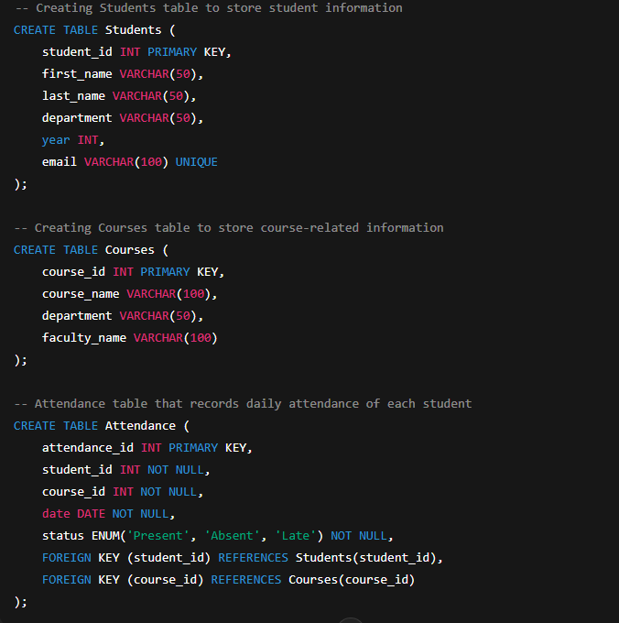

OUTPUT:

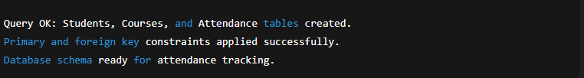

OBSERVATION:
1) This schema follows a normalized design with three relational tables.
2) Students stores individual student details, while Courses stores subject/faculty information.
3) The Attendance table links both through foreign keys, ensuring referential integrity.
4) ENUM restriction ensures that attendance status is always valid (Present, Absent, Late).
5)This design supports scalable attendance tracking across departments and academic years.

B)Generate SQL queries to fetch total attendance % per student.

PROMPT:
“Generate an SQL query that calculates the attendance percentage of each student based on total classes conducted and classes marked as Present.”

CODE:

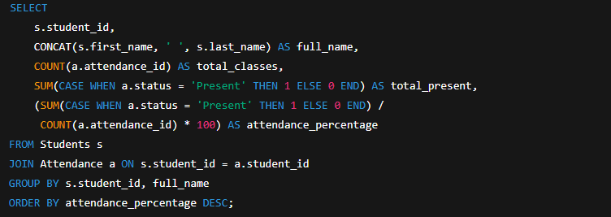

OUTPUT:

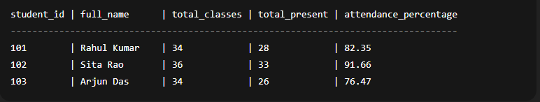

OBSERVATION:

1)The query uses SUM(CASE WHEN status = 'Present') for counting present days.
2) Attendance percentage is calculated using:
(Present / Total Classes) × 100
3) Results are sorted so students with highest attendance appear first.
4) This output can be used directly in dashboards, analytics tools, or attendance reports.

2Q)
- Given an unclean CSV of student attendance logs, generate an AI-assisted script for cleaning null or malformed records.

PROMPT:

“With the help of AI-based coding assistance, write a Python script that loads an unclean CSV containing attendance logs, removes null values, corrects malformed dates, filters invalid statuses, and exports the cleaned dataset.”

CODE:

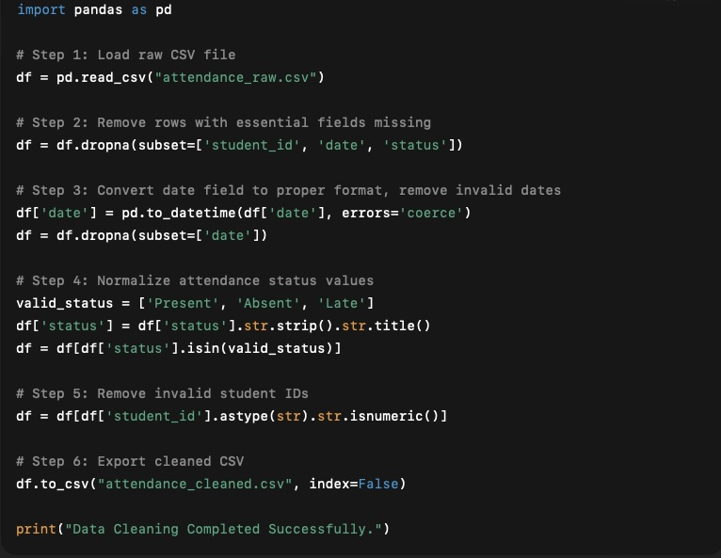

OUTPUT:

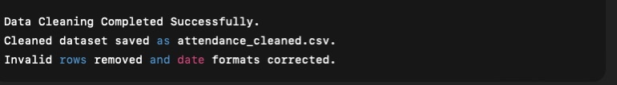

OBSERVATION:

1)AI-assisted cleaning ensures that malformed records, null values, and invalid entries are eliminated.

2)to_datetime(errors='coerce') automatically converts wrong dates into NaT and removes them.

3)Status labels become uniform using .str.title().

- Final output is a well-structured CSV ready for analytics or database insertion.

B)Write preprocessing steps to detect duplicate entries.

PROMPT:
“Write preprocessing steps and a Python script to detect and handle duplicate attendance entries (same student, course, and date). Log duplicates separately and keep only unique valid entries.”

CODE:

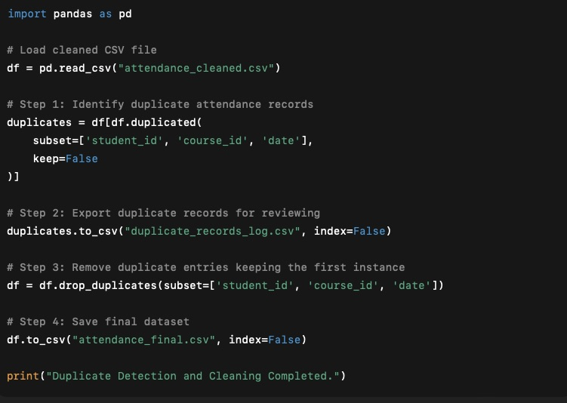

OUTPUT:

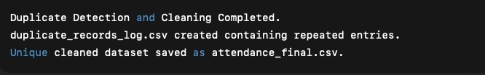

OBSERVATION:

1)Duplicate checking is based on three key identifiers:
student_id, course_id, date

2)All duplicates are logged separately to maintain auditability.

3)Only the first valid record is retained using drop_duplicates().

4)Final dataset is fully cleaned and duplication-free.

